Building Security Into Every Stage of the CI/CD Using DevSecOps

Revanth Kumar T S¹, Sanket², Shakthi Vel K³, Vignesh P⁴, Sameena H S⁵, Ashwini C⁶
^{1,2,3,4} UG Scholar, Computer Science and Engineering, Global Academy of Technology, Bengaluru, India
Email: { revanthkumarts123, sankethcoding, shakthivelk1124, palanivignesh31}@gmail.com
^{5,6}Assistant Professor, Computer Science and Engineering, Global Academy of Technology, Bengaluru, India
Email: {sameena.hs, cashwini }@gat.ac.in

Abstract— DevOps helped to advance software delivery using a blend of development and operation practices, to provide faster and more dependable releases. Security was still usually perceived as an after thought towards the end of software development, therefore problems with security are only uncovered toward the end. DevSecOps tries to improve on this by embedding security within the different steps of the CI/CD pipeline.
This paper presents a secured DevSecOps pipeline using Git & Jenkins for CI, SonarQube for Static Code Analysis, Trivy for Container Security Scanning, OWASP ZAP for Dynamic Application Security Testing, Docker & Kubernetes for containerized deployment and Prometheus & Grafana for monitoring. The presented pipeline automates security verification right from the source code level to the runtime, which detects security vulnerabilities in prior to production deployment while ensuring Continuous Delivery of software.
As shown in the demonstration, by embedding checks at different stages of the CI/CD pipeline: an organization can get enhanced application visibility by identifying vulnerable code early, reduce security testing load, deploy more reliably, and gain visibility into application health with automated monitoring. The framework offers a pragmatic method for developing efficient and secured software delivery.

Index Terms— DevSecOps, CI/CD Pipeline, Static Application Security Testing (SAST), Dynamic Application Security Testing (DAST), Container Security, Continuous Monitoring
I. Introduction
CI/CD pipelines never quite took hold across the field overnight. Early software teams managed releases manually, and the problems that created were hard to ignore — broken builds, missed deadlines, and update cycles that dragged on far longer than anyone wanted. When agile began gaining ground, the expectation of frequent, working releases made manual delivery genuinely unworkable. Pipelines filled that gap. They absorbed the repetitive parts of the release process and made shipping software something teams could do regularly without it turning into an ordeal every single time.
Containers arrived around the same period and were dealing with a different but equally familiar frustration. The scenario most developers have lived through at least once — code that runs cleanly on a local machine and then breaks the moment it lands somewhere else — was exactly what containers were built to address. The environment follows the application. This eliminates any disparity that previously led to constant surprises just before go-live.
As such systems became more prevalent, however, vulnerabilities in their architecture started appearing. Before DevSecOps existed, the security tests were being performed during the last stages of software development just before it was being released. This was a bad way of working; however it was acceptable at the time because there were only a handful of new releases a couple of times per month. However, as the rate of releases into production was being pushed to one or several times per day, or per hour, it was no longer acceptable to be performed tests between the new releases and the new release. This generated serious problems; if a bug is discovered weeks after the development has been undertaken then it can be very complex to find a suitable fix, and also the fix could also have consequences to both business and technical decisions that would have been made at the beginning of the development. DevSecOps was born because software developers and IT professional were facing many of these problems; its basic underlying rule is that there cannot be security added to something that did not had it from the very first day.
For many companies, the challenge was not about convincing them to use a security solution, but to integrate a security solution into their already live production systems. Implementing a change to a live production system will always be risky and most engineering teams were already over-burdened and couldn't justify spending extra time finding a security solution. It was a problem with tooling as well; the point of a scanner is to provide a list of vulnerabilities, but a scanner can easily be misunderstood, or simply overlooked if the person viewing it doesn't truly understand what the results mean.

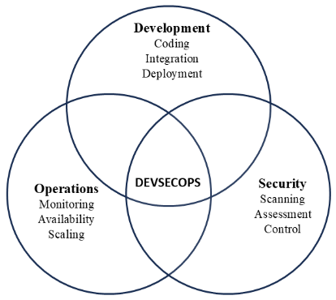

Fig . 1. DevSecOps
Fig. 1 illustrates the relationship between the three key components of DevSecOps. The development component entails code creation, system integration, and release management. On the other hand, operations involve the technical component of the system and ensure its availability, reliability, and scalability. Lastly, security encompasses scanning, identification, and controls. As illustrated by the figure below, these three components are not sequential; rather, they are concurrent. Each component influences the other two. The concept here is that if one of these three components were separated from the rest, the whole concept of DevSecOps will crumble.

II. LITERATURE SURVEY
One thing early DevSecOps research kept bringing up was that security was getting pushed to the side inside DevOps pipelines. It was not being ignored completely, but it was clearly not being treated as a priority either. Nikolov and Aleksieva-Petrova (2023) wanted to look at this more closely and chose Jenkins as their environment. They put Snyk and OWASP ZAP into the pipeline at various points. The idea was to check which stages were actually picking up security issues and which ones were missing them. Finding vulnerabilities before deployment was shown to be possible, which was a useful outcome. That said, container security was not part of what they looked at, and nothing was set up to monitor the system after it went live[1].
Marandi et al. (2023) took a different approach entirely. Rather than Jenkins they used GitHub Actions as the base for their pipeline. Snyk and StackHawk were the tools they worked with, and Docker was running alongside everything. They did not stop at just scanning either — dashboards were added and parts of the remediation process were automated, so when issues came up the team had less manual work to get through. Even with those additions though, scanning container images and watching the runtime environment were still not covered[4].
Around this same period some researchers started looking beyond the technical side of things. Nayanajith and Wickramarachchi (2024) found that the biggest obstacles teams were hitting during DevSecOps adoption were not really about which tools to pick or how to configure them. Skill gaps were a common issue, and so was pushback came from engineers who were not comfortable changing approaches that had gone unchanged for a long time. On top of that, different groups within the same organisation were often not communicating well with each other. Fixing the technical setup was the easier part of the problem — shifting how people actually worked and collaborated on a daily basis was where things got genuinely difficult[7].
Bautista Ramos and Yoo (2025) took a step back from looking at any one specific case. Their work addressed several different aspects of already published studies, going through them to build up a general picture of what the research in this area actually looked like. What kinds of vulnerabilities were showing up most often across the literature, and what were researchers actually proposing to deal with them — those were the questions they were trying to answer. what became particularly apparent through their review was that a significant portion of the research they looked at had gone unexamined until that point outside of controlled settings. That is a real limitation because it leaves open the question of how any of it would hold up in a live environment where conditions are messier and less predictable[11].
Some studies published in recent years started putting Jenkins, Docker, and Kubernetes together within identical pipeline and adding Prometheus and Grafana on top. Security was still part of the focus but so was overall system performance. Having Prometheus collecting data and Grafana displaying it meant teams gained genuine visibility into system behavior with their systems after deployment rather than discovering an underlying issue only after users started reporting problems. It was further noted that Trivy helps to check container-related issues[2][3][10].
In DevSecOps, some studies follow the CAMS model. This mainly includes culture, automation, measurement and sharing.. These factors are seen as important when applying DevSecOps in real situations These aspects are seen as useful when trying to use DevSecOps in practical situations. These factors matter when applying DevSecOps in real environments. It demonstrated a measurable effect on an effect on a strong effect on successfully applying DevSecOps in real environments[8][13][14].
Research has also examined improving the monitoring phase using machine learning. A hybrid intrusion detection system is applied during continuous monitoring, which helps in detecting threats with good accuracy. Still, these methods remain limited to specific datasets and need more real-world validation.[15]
From these studies, it is observed that DevSecOps is improving, but some gaps still remain. From these studies, it appears that many works focus only on specific parts such as scanning or monitoring, but do not cover the complete pipeline.
Looking across these studies, a pattern becomes clear — most of them tackle one or two pieces of the pipeline rather than treating it as a whole. This work takes a different angle by connecting those pieces into something more complete. Static testing, dynamic testing, container scanning through Trivy, and continuous monitoring via Prometheus and Grafana are all brought into a single pipeline rather than handled separately.
This leads to the necessity of merging multiple stages of the pipeline into one system.This work tries to piece these things together in a way that security can be checked at every step along the way.
III. DEVSECOPS PIPELINE MODEL
This system integrates security in DevSecOpspipelinefor CI/CD The idea of implementing a secure DevSecOpspipeline that security measures are adopted throughout the development and implementation phases of software development and execution. Most DevOpspipeline in the software industry performs security checks only at the end phase, unlike this DevSecOpssystem that adopts security checks throughout the lifecycle starting from the source code compilation to the runtime of the software which minimizes security threats and manual effort in the deployment of software.
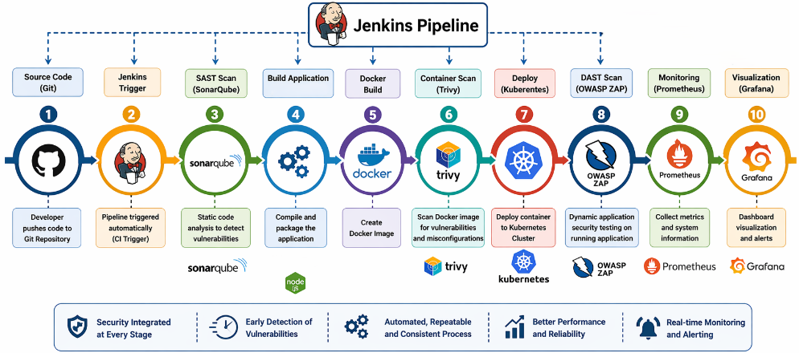

Fig. 2. DevSecOps
Fig. 2 represents a Jenkins pipeline workflow that starts when a developer commit code in a Git repository. Code commit initiates Jenkins pipeline for the entire workflow, which then calls SonarQube forStatic Application SecurityTesting(SAST)to identify bug, code quality issues and security vulnerability in source code, If the code satisfy the defined quality gate then the application will compile and packaging then a docker image is build.
Once the container image is built, it’s security tested with Trivy for any vulnerabilities, unsafe packages, or configuration files. If the container passes this security test, then it’s deployed to the Kubernetes cluster. Dynamic Application Security Testing is performed by OWASP ZAP by checking the deployed application for OWASP-recognized vulnerability type like SQL injection, Cross-site Scripting (XSS), insecure configurations and more.
Prometheus also enables the visibility needed in production by collecting resource usage metrics for services and system metrics such as system performance, memory usage etc.. These can be displayed in dashboards using Grafana, so operations can watch their applications run and trigger alerts in case of abnormal performance or failures in the systems running the software. With all of these features-static analysis, container security scanning, dynamic analysis, automated deployment, and continuous monitoring in place-this system provides an easy-to-implement solution for building secure, reliable, and continuously monitored delivery pipeline.
IV. METHODOLOGY
This proposed DevSecOps framework automates security testing in the CI/CD pipeline, includes container security and automated deployment, and relies on continuous monitoring to create secure software. DevSecOps has a step-by-step flow that relies on automation to handle individual steps in the SDLC as it processes the code.
When a developer pushes their code to a Git repository, every code push will automatically trigger a Jenkins pipeline, usually through a webhook. This automation process ensures that each code change passes a certain validation procedure before being pushed to production. The entire pipeline is orchestrated by Jenkins as it executes all downstream stages in sequence, thus providing the automation pipeline the consistency that ensures reusability.
The 1st step is security validation using SonarQube, doing Static Application Security Testing (SAST) on the source code. The source code of an application is analysed and inspected for bug issues, security vulnerability, code smells, duplicate code and maintainability. A quality Gate is used to make sure if the application fulfills all requirements for quality standards. If code passes the quality gates, then code moves to build.
Once validation passes, Jenkins builds the application and creates it as a deployable artifact. We then build a container image for that artifact in order to make sure that the application will be executed in the same way no matter whether it’s development, testing, or production. Just before deployment, the container image is checked for potential vulnerabilities (using Trivy) and outdated packages, and, when serious issues are found, is stopped from moving on.
OWASP ZAP dynamically scans the application (DAST). Instead of looking for runtime vulnerabilities on the running application, DAST focuses on simulating user interaction to find security flaws that the application may exhibit at runtime, like:SQL injections Cross site scripting(XSS) Insecure Http headers Unauthenticated users The final layer in this security testing process is DAST.
Monitoring & Visibility (Continuous) The last part to our pipeline will involve continuous monitoring and visibility into how the deployed application and its infrastructure is performing. Prometheus will scrape the application and infrastructure metrics that our application is producing, such as memory and CPU usage, response times, and availability. Grafana will give us a view into this data through various dashboards and trigger alerts if the application metrics go above a certain threshold. Continuous monitoring allows for quick detection of anomalies and pro-active management of the deployed application.
Table I provides a summary of the tools used in the DevSecOps pipeline proposed. Through early detection of security threats, minimization of human work and a stable deployment cycle, the proposed technique achieves higher levels of software reliability, automation and security in the entire software lifecycle.
Table I: Tools Used in DevSecOps Pipeline
Sl. No | Tool | Category | Purpose
1 | Git | Version Control | Manage source code and trigger the CI pipeline
2 | Jenkins | CI/CD Automation | Automate build, testing, and deployment
3 | SonarQube | SAST Tool | Perform static code analysis and quality checks
4 | Docker | Containerization | Package the application into a container image
5 | Trivy | Container Security | Scan container images for vulnerabilities
6 | Kubernetes | Container Orchestration | Deploy, manage, and scale containers
7 | OWASP ZAP | DAST Tool | Perform runtime security testing
8 | Prometheus | Monitoring | Collect application and infrastructure metrics
9 | Grafana | Visualization | Display dashboards and generate alerts
V. RESULTS AND DISCUSSION
The DevSecOps pipeline concept that was designed, was developed and tested with Git, Jenkins, SonarQube, Docker, Trivy, Kubernetes, OWASP ZAP, Prometheus, and Grafana. The running of the pipe line confirmed security testing had been incorporated at every step of the CI / CD process and the delivery of software remained automated.
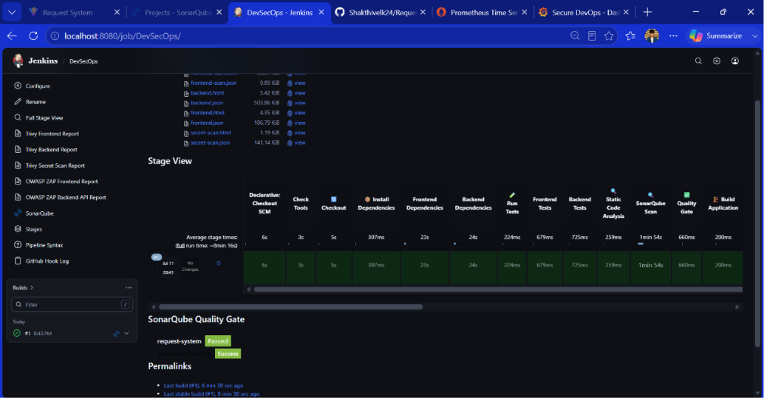

Fig. 3. Jenkins Pipeline Execution
Fig. 3 indicates that Jenkins had performed all phases of the CI/CD pipeline, source code check out, installing dependency, application build, static code analysis, testing and Quality Gate validation, that meant all the phases completed successfully. From which, we can come to conclusion that the pipeline developed has been used to automate the software delivery, without human involvement and that security measures had been checked at all phases of the Software Development lifecycle.
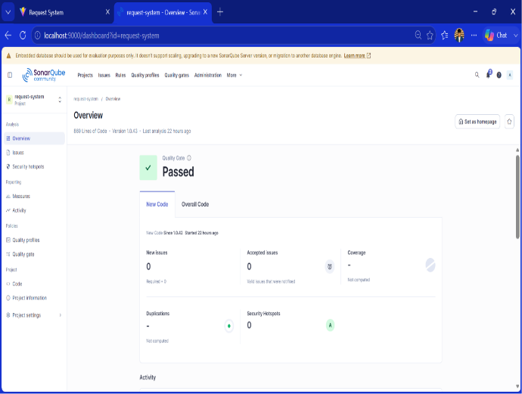  Fig. 4. SonarQube Quality Gate result. | 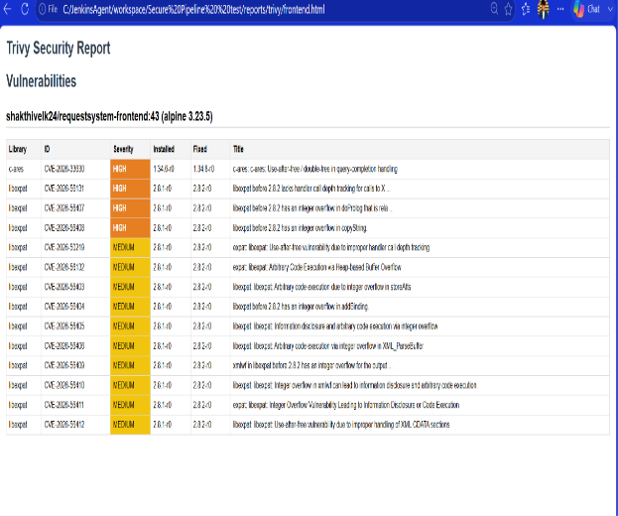  Fig. 5. Trivy Security Report
Fig. 4 shows the Static Application Security testing conducted using SonarQube. The analysis passed the Quality Gate and there were no new issues or security hotspots found in the source code that was scanned. This confirmed the application meets the quality criteria and security standards required for the application to go to deployment. Fig. 5 shows the security verification result of the container image via Trivy. In the figure, Trivy has found vulnerability with different degrees in the container image, which allows developers to notice some of the old packages and the security holes in the container image prior to it is delivered to production environment. Having the container image scanning embedded in the CI/CD process may reduce the chances of delivering potentially unsafe software to production.
Dynamic Application Security Testing (DAST) was conducted on the application after its deployment using OWASP ZAP. Fig 6 Shows the resulting report that did not list any high-risk vulnerabilities but did have few medium and low-risk alerts which means that the application met all basic requirements on runtime and suggested areas to strengthen security. Continuous monitoring was executed utilizing Prometheus and Grafana. In Fig. 7 Prometheus sampled metrics related to runtime (e.g. Total http requests, request per second, latency of response and number of server errors) and the same metrics were displayed by Grafana through customizable dashboards. The system enabled continuous observability of application behavior and allowed the quick detection of abnormalities of the running system.
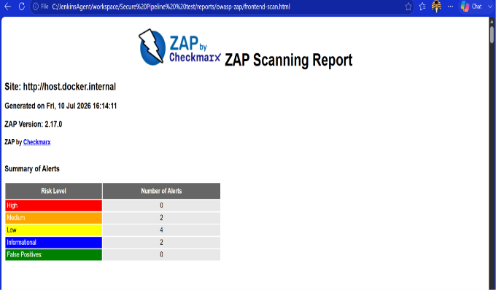  Fig. 6. OWASP ZAP Scan Report | 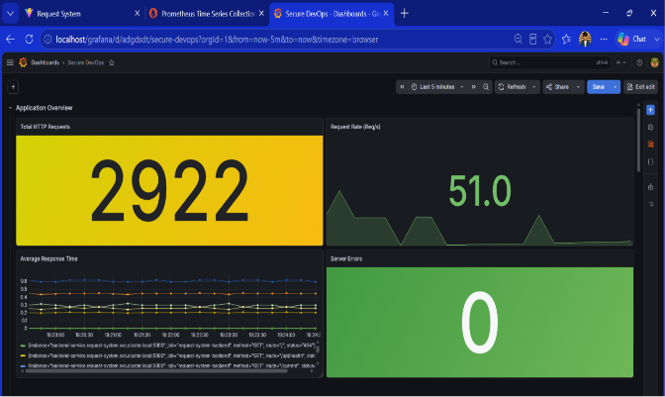  Fig. 5. Grafana Monitoring Dashboard
In summary, the implementation shows that a single DevSecOps pipeline that integrates static code analysis, container vulnerability scanning, dynamic application security testing, automated deployment, and continuous monitoring can significantly help detect vulnerabilities early, minimise manual security labour, improve deployment confidence and provide persistent operational insight during the software development life-cycle.
VI. COMPARISON WITH RELATED WORK
Looking at earlier studies, most of them zeroed in on one or two parts of the pipeline — some focused purely on static code analysis, others only tested after deployment was already done. Security ended up being handled in patches rather than as something that ran through the whole process consistently.The pipeline in this work covers all three levels — code, container, and post-deployment — which means security gets a look-in at each meaningful point rather than just one. That shift alone changes how vulnerabilities get caught and dealt with.
Something else that stood out in prior work was the absence of any monitoring after deployment. A lot of implementations simply stopped once the application went live. This work keeps going beyond that point, with Prometheus and Grafana staying active so the system can be watched while it is actually in use.Stringing these stages together rather than treating them in isolation is what makes the difference — fewer gaps, fewer surprises, and less room for something to quietly go wrong. A side-by-side comparison of existing and proposed approaches is laid out in Table II below.
Table II: Comparison of Different Approaches
Feature | Existing Work | Proposed Work
Static Code Analysis (SAST) | Available | Included
Dynamic Security Testing (DAST) | Partial | Included
Container Vulnerability Scanning | Limited | Included
Automated CI/CD Pipeline | Partial | Included
Kubernetes Deployment | Limited | Included
Continuous Monitoring | Limited | Included
End-to-End DevSecOps Pipeline | Not Fully Covered | Included
VII. CONCLUSION
In this study, we proposed a secure DevSecOps framework which can incorporate security throughout the CI/CD pipeline stages. Our proposed secure DevSecOps framework integrates Git, Jenkins, SonarQube, Docker, Trivy, Kubernetes, OWASP ZAP, Prometheus and Grafana, thereby enabling to secure the software development pipeline and continuous validation on the application security throughout the CI/CD pipeline. It was validated through implementation, that it is feasible to find out security issues earlier, increase deployment reliability and decrease human security resources if static code analysis, container security vulnerability scanner, application vulnerability scanner, and continuous monitoring application is seamlessly connected in a workflow. The outcome of this study provides evidence that our proposed system has correctly executed the whole pipeline, and verified automatic validation on application security throughout SDLC pipeline successfully.
Future enhancements to the framework include the incorporation of policy-as-code, Infrastructure as Code (IaC) security scanning and AI driven vulnerability detection.

References
- L. A. Nikolov and A. P. Aleksieva-Petrova, “Action Research on the DevSecOps Pipeline,” in Proc. 2023 Int. Scientific Conf. Computer Science (COMSCI), Sofia, Bulgaria, 2023.
- M. A. Aljohani and S. S. Alqahtani, “A Unified Framework for Automating Software Security Analysis in DevSecOps,” in Proc. Int. Conf. Smart Computing and Applications (ICSCA), Riyadh, Saudi Arabia, 2023.
- N. M. K., M. B. S., N. Khandelwal, N. Pai, and S. L., “CI/CD Pipeline with Vulnerability Mitigation,” in Proc. Int. Conf. Recent Advances in Science & Engineering Technology (ICRASET), Bangalore, India, 2023.
- M. Marandi, A. Bertia, and S. Silas, “Implementing and automating security scanning in a DevSecOps CI/CD pipeline,” in Proc. World Conf. Communication & Computing (WCONF), Raipur, India, Jul. 2023.
- S. Yulianto and G. N. C. Ngo, “Enhancing DevSecOps Pipelines with AI-Driven Threat Detection and Response,” in Proc. Int. Conf. ICT for Smart Society (ICISS), Quezon City, Philippines, 2024.
- M. Voggenreiter, F. Angermeir, F. Moyón, U. Schöpp, and P. Bonvin, “Automated security findings management: A case study in industrial DevOps,” in Proc. 46th Int. Conf. Software Engineering: Software Engineering in Practice (ICSE-SEIP), Apr. 2024.
- A. Nayanajith and R. Wickramarachchi, “Challenges affecting the successful adoption of DevOps practices: A systematic literature review,” in Proc. 4th Int. Conf. Advanced Research in Computing (ICARC), 2024.
- R. Rajab and M. Alnoukari, “DevOps Integration With Capability Model Maturity Integration: A Systematic Mapping Review,” IEEE Access, vol. 13, pp. 31829–31852, 2025.
- N. Dinh et al., “Enhancing smart contract security through DevSecOps: An adaptive approach for vulnerability detection,” IEEE Access, vol. 13, pp. 159454–159520, 2025.
- R. Ashtagi et al., “Building resilient CI/CD pipelines: A DevOps security-first framework,” in Proc. Int. Conf. Computational, Communication and Information Technology (ICCCIT), 2025.
- R. C. B. Ramos and S. G. Yoo, “Cybersecurity in DevOps environments: A systematic literature review,” IEEE Access, vol. 13, pp. 191959–191980, 2025.
- S. A. Ruk et al., “Effort estimation in Agile and DevOps: A systematic literature review of stakeholder dissatisfaction,” IEEE Access, vol. 13, pp. 167925–167960, 2025.
- N. S, P. Manja, P. Mathur, and P. B. Honnavalli, “Extensive review of threat models for DevSecOps,” IEEE Access, vol. 13, pp. 45252–45274, 2025.
- M. A. Akbar and A. A. Alsanad, “Empirical investigation of key enablers for secure DevOps practices,” IEEE Access, vol. 13, pp. 43698–43710, 2025.
- J. Ababneh et al., “Enhancing DevOps continuous monitoring phase: Hybrid intrusion detection and ensemble learning system,” IEEE Access, vol. 14, pp. 4733–4755, 2026.

